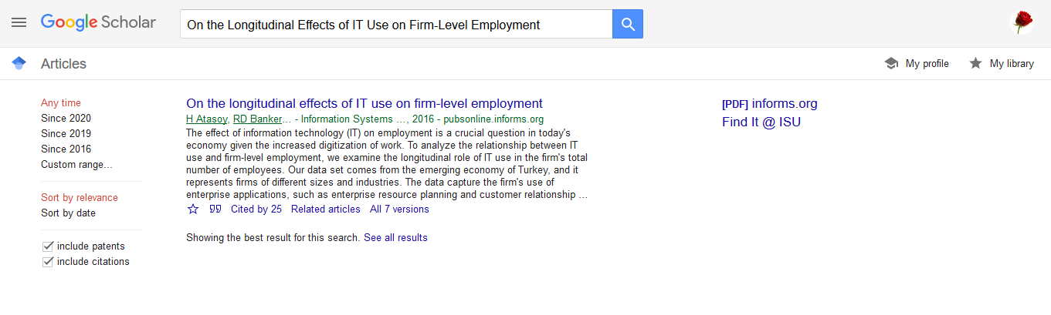

**The APA citation**

Atasoy, H., Banker, R. D., & Pavlou, P. A. (2016). On the longitudinal effects of IT use on firm-level employment. *Information Systems Research*, *27*(1), 6-26.